Issues caused by poorly designed circuits

* Difficulty debugging: tracing will be difficult

Breadboard:

* power rail,
* ground rail,
* DIP IC Break
* conductive strips

Color coding wires (Suggestions)

* Be sure to be consistent
* Black: ground
* Red: power 5V
* White: power higher voltage
* Organe: communication Tx
* Green: communication Rx
* Blue: analog measurement
* Purple: PWM output

Ground

* Voltage is only measured as the difference in potential between two points
* Typically, a 0V point in a circuit is defined as the “ground
* Having a common ground is important
* You can have separate power sources for different parts of the circuit, but make sure you have a common ground relative to each other. Connect them and short them
  + If you have multiple grounds, you won’t know the voltage of the two grounds relative to each other
  + You might accidentally give more than 5V of power for the arduino analog pins, which will break the pins

Noise

* Undesirable random oscillation of the voltage/current, very quick changes
* Can come from various sources: Switched power supplies, PWM signals, microcontroller

Electromagnetic interference

* Basics
  + A changing magnetic field induces a current in nearby wires, and vice versa
* Any wire with changing current can generate or pick up EM waves, other wires will pick up this noise

Interference in **servomotors**

* Changing angle based on width of pulse (PWM signal)
* If the current is changed due to EM waves, servomotors will have a hard time interpreting the signal

What can we do about electromagnetic interference problems

* Twisted pair wiring
  + Opposite induced currents cancel each other
* Shielding
  + Keeps noise either in or out
  + Can shield both wires/cables and integrated circuits
  + Shielding should be grounded (dissipate any energy if they pick up)
  + Use foil, braid, or a combination of them to shield
* Ferrites, time averaging (only in some cases)
  + Ferromagnetic material
  + Wire passes through the core
  + Attenuate high-frequencies (acts as an inductor at high frequency), can be noise or signals
  + Can cause degradation of square wave signals, such as PWM (shaping square wave signals into rounded signals)
  + May not be effective at low frequencies
* Time averaging in code
  + Averaging several discrete measurements to remove noise
  + Only works if noise is “zero-mean”
    - If non-zero mean, e.g. if the voltage is constantly decreasing over time, then you won’t be able to detect it
  + Can cause “smearing”
  + Averaging time is on the same order of magnitude as the signal period

Switching noise

* When using a switched power supply (buck, boost, or buck-boost converter) is used, the rapid on/off of the circuit will cause high frequency oscillations in power lines
  + Due to parasitic line capacitances and inductances
* Can cause problems if the harmonics approach the magnitude of the voltage on the line (wavy voltage)

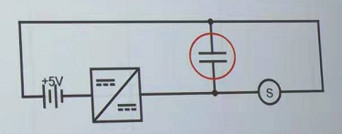

Mitigating switching noise

* To fix it, we need to use power line filtering
  + Ferrites can be used for this
  + Parallel filtering capacitors (polarized and unpolarized) can be much smaller and more effective
    - Effectively absorb high frequency noise components
    - Large capacitance values will absorb at lower frequencies
    - Many ICs will specify values of capacitors for proper operation

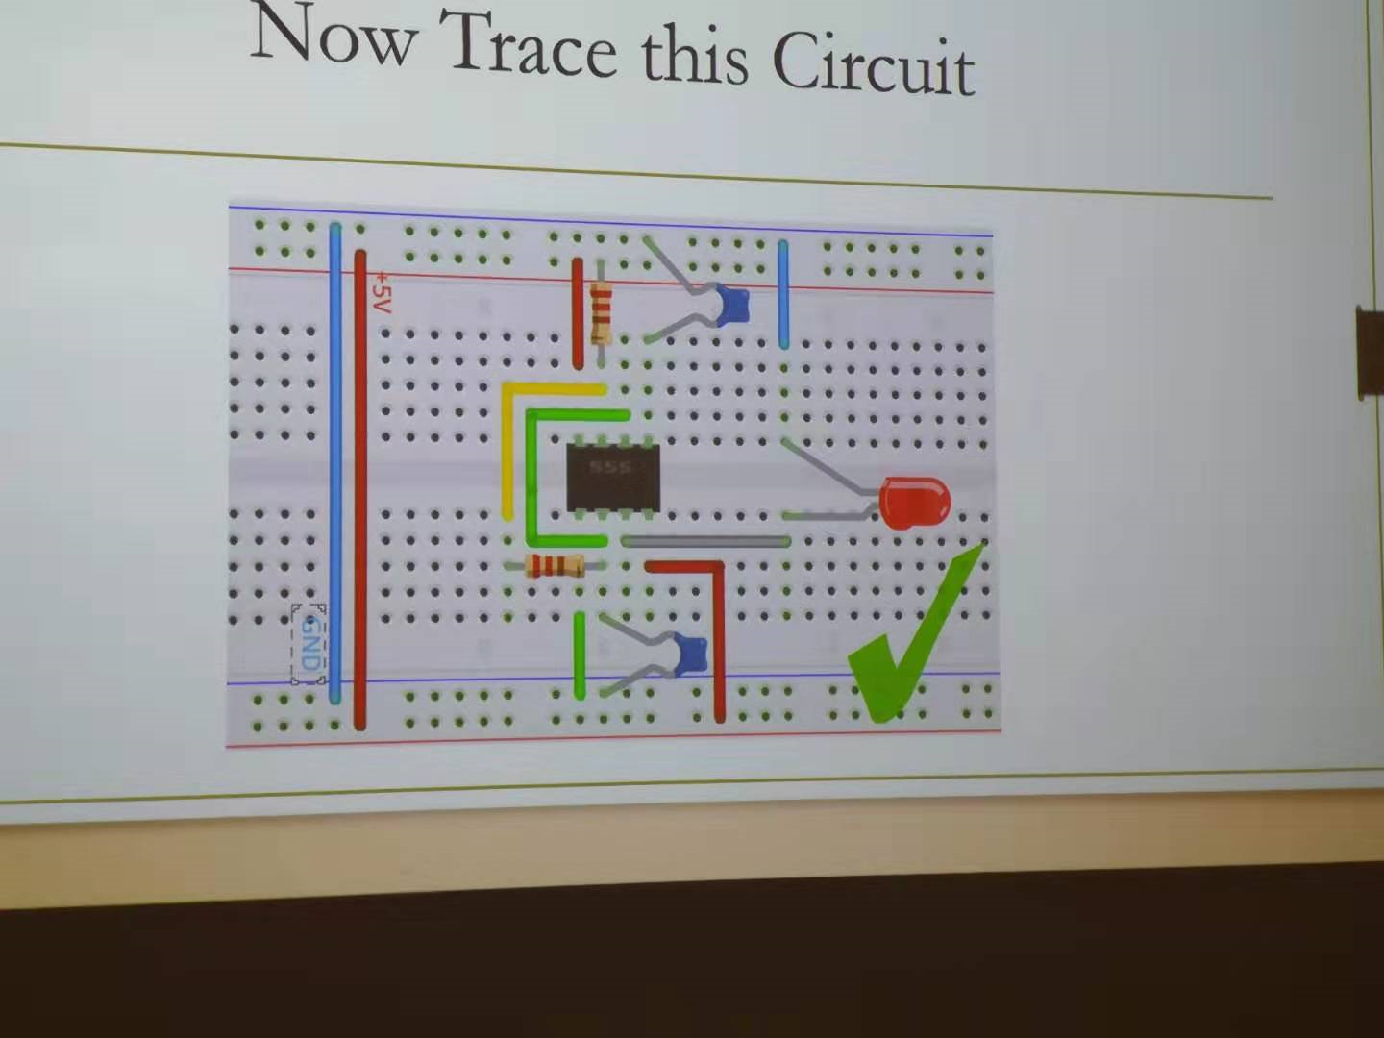

Voltage and current

* Only dealing with DC in this course

Wires

* Shorter and wider → more resistance
* Stranded: more flexible, generally easier to work with
* Solid core: higher current handling, better heat conduction
* Jumper wire: no soldering needed

Resistors

* Passive component, dissipates power, limited by how much power they can safely dissipate before melting
* Used to limit current draw
* Available as “barrels”, surface mount, etc
* What resistance should I use to draw 100 mA from a 10V power supply, what power dissipation?

Capacitors

* Stores and releases a small amount of charge (F)
* Various types, some polarized, some non-polarized (don’t need to worry about which way to plug in)
* At steady state, act as open circuit, will act to quickly absorb current spikes from transient

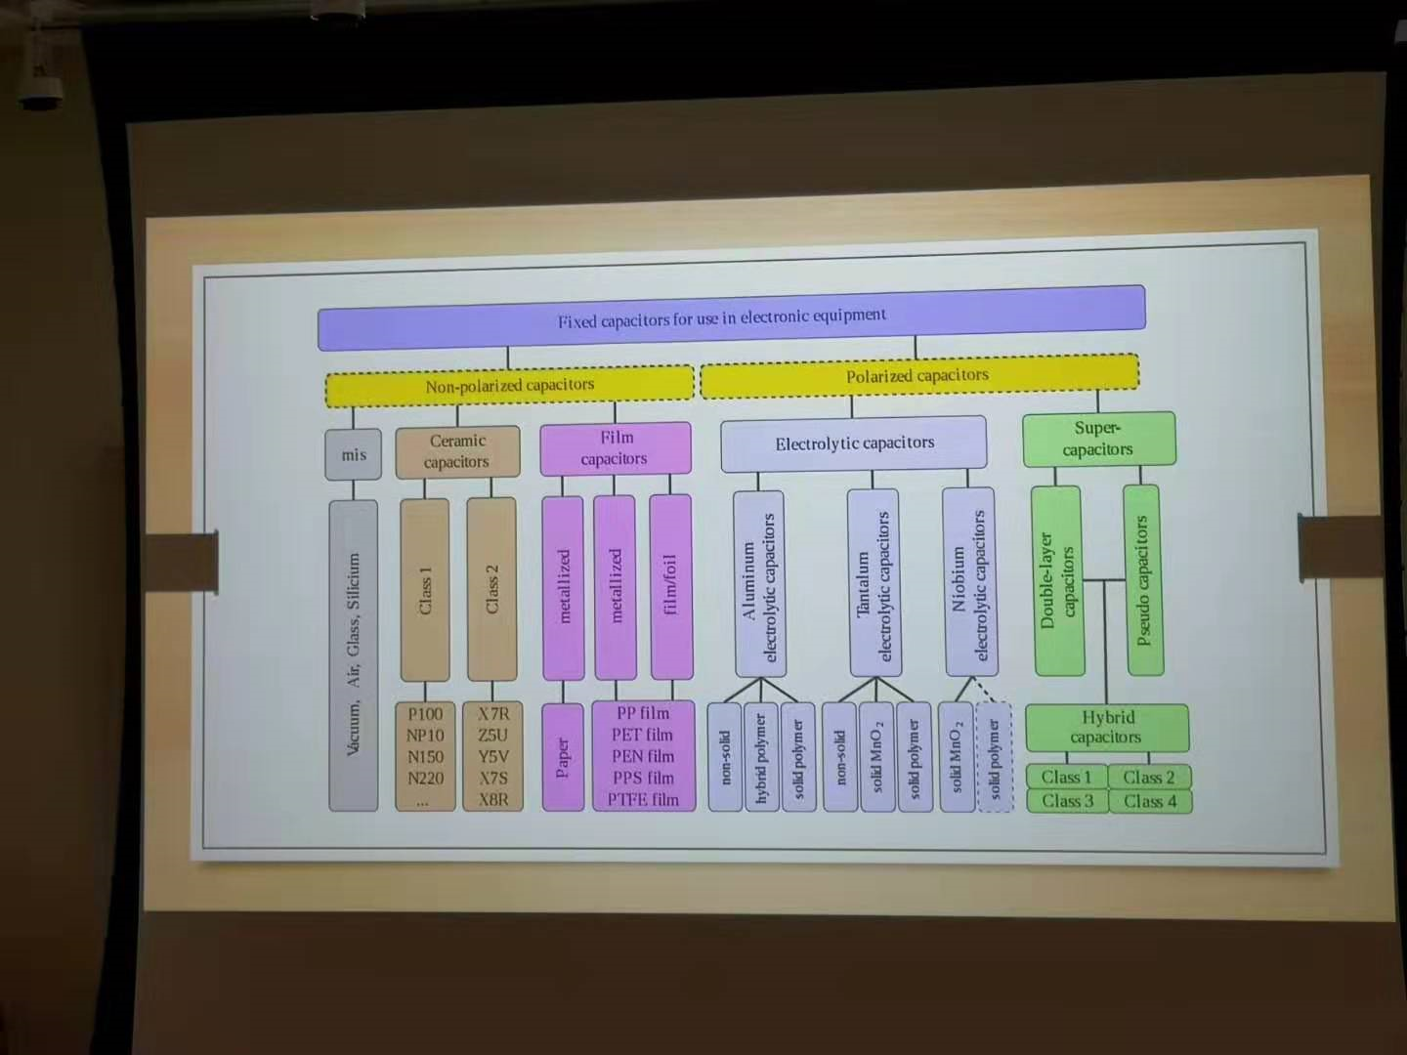

Inductor

* As current flows through, generates a magnetic field, that resists changes in current
* Acts to slow down current
* At steady state, acts as a short circuit, acts to block transients and smooth out response to changes
* Combined with capacitor, can form LC circuit

Motors

* Typically will act as a resistor in a circuit in steady state, draw power and dissipate energy
* Has voltage rating, draw amount of current they need (has circuit embedded in it usually to control the circuit)

Switch

* Types: single pole single throw, single pole double throw, double pole double throw (doesn’t have an off state)
* Throw: number of position

Transistor

* Semiconductor, act like switches
* Switch electrically, solid state, no moving parts, incredibly fast response
* Power devices that may take more current than an Arduiino can provide over GPIO
* Many different types
* Still have current/voltage limits, depending on type/size

Relay

* Electromechanical switch: often uses magnetic fields to open/close
* Latching/non-latching available
* Requires more power than a transistor to open/close
* Much greater power handling capability

Diodes

* One-way current controller, prevent current from flowing in one direction
* Characterized for a forward voltage drop, breakdown voltage, and current limit
  + Signal vs. rectifier (power) diode (one used for signal, one used for power)

LED

* Acts as a diode, but emits light when current passes through it
* Follows the same IV curve as a normal diode, forward voltage is normally higher
* Brightness depends on current passing through diode, resistor in the circuit limits current

Programmable DC Power Supplies

* Useful for testing
* Settable voltage and current limits
  + Analog vs. Digital
* More advanced units have separate power on and enable switches: multi-channel and digital control also available

Batteries

* Voltage - nominal operating voltage: more series cells, higher voltage
* Capacity - amp-hours: more parallel cells, higher capacity (Ah)
* Discharge: amperage pulled from battery relative to its total capacity
  + Discharge rate
* Different battery chemistries good for different applications
* Use batteries in series instead of one battery to provide that same voltage, but they are heavy

Linear regular

* Userful power applications
* Provides a constant voltage lower than the supply voltage
* Excess power dissipated as heat
  + Seriously, these can get really hot
  + Pd = (Vin-Vout) Iin
* No switching noise

Switched power supplies

* More efficient than linear regulators
  + Efficiency in the range of 95-98%
  + Don’t heat up as much, can handle higher currents/voltages
  + More complex, larger
* Can both increase or decrease voltage
* Can cause switching noise on power lines

Some basic circuits

* Voltage divider (use Ohm’s law to find voltage drop across different resistors)
* LED dimmer
* Pull-down resistor:
  + used to avoid “floating” digital input pins, keeps the voltage at the appropriate level, 5 when switch is closed, 0V when open
* Pull-up resistor:
  + Same thing as pull-down resistor, but with power and ground reversed

Integrated circuits

* Discrete: discrete components require more space but more flexible
* Integrated circuit has huge reduction in size, and generally higher efficiency and lower cost
* Consider different footprint/package avilable